PRACTICAL EXAMINATION 01
Subject code: FER202 - FALL 2025
Duration: 85 minutes
You are required to build a Personal Budget Management web application where a user must first log in, and then can add, edit, or delete daily expenses, view expense totals and filter user expense by category. You must use ReactJS (functional components), React Router, Redux Toolkit, Hooks, Bootstrap or React Bootstrap, Axios, and JSON Server to design the UI according to the given requirements.
Note:
- Students are allowed to use resources stored on their computers but are not allowed to use the Internet during the test (except for submitting the exam).
- If identical test results are detected, the students’ work will receive a score of zero.
- If the code does not run or does not use db.json in Given folder, the students’ work will receive a score of zero.
- Students will receive fully 10 marks if they use Redux Toolkit or useContext combined with useReducer; otherwise they get 9 marks.
- Submit a folder containing your project (excluding node_modules) and a readme.txt (listing installed packages and how to run, if applicable).
Questions
- Create a React application named fer202-02
- Setup JSON Server (0.5 mark)
- Copy a file named db.json in Given folder to initialize a virtual server using JSON Server with the sample data below:
- Project structure (0.5 mark)
- Organize the source into meaningful folders: components, pages, contexts, services, routes…
- Authentication (2.25 marks)
- /login page with username and password fields (0.5 mark).
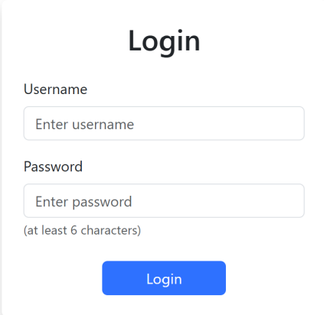
Validate that both fields are not empty (0.25 mark).
Display an error message (e.g., "Username and .password are required") if the user tries to submit an empty form (0.25 mark)
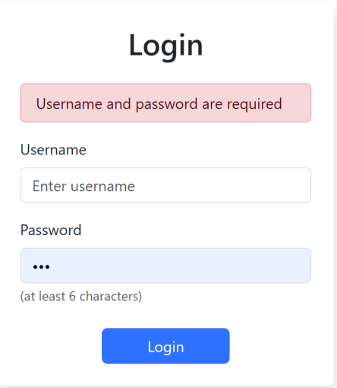
Optionally, check that the password has at least 6 characters (0.25 mark).
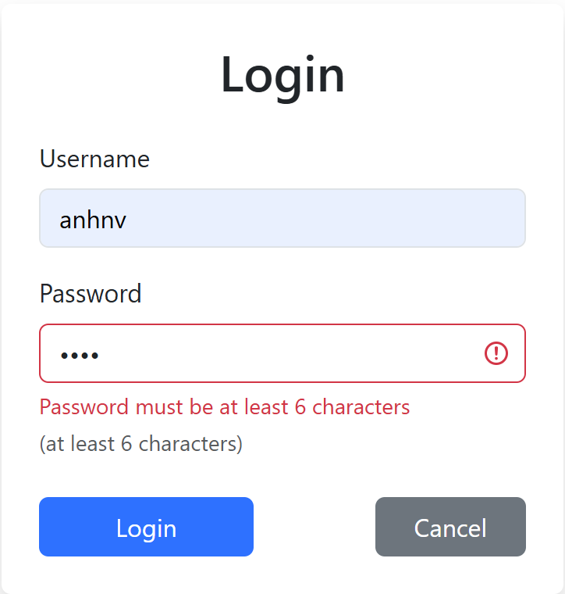
- On success: redirect to /home (0.5 mark)
- Call router successfully: /login (0.25 mark), /home (0.25 mark)
- Monthly Dashboard (1.5 mark)
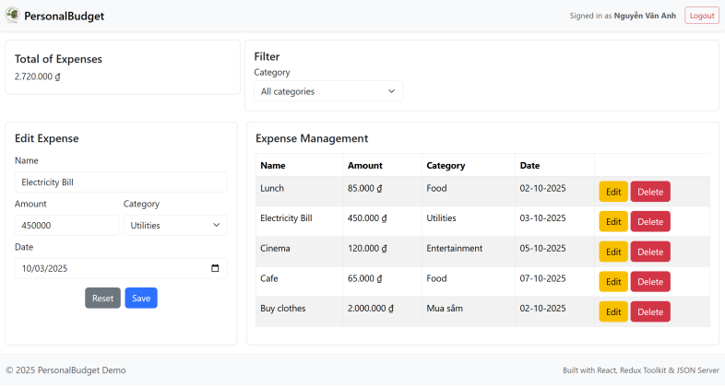

UI Components
Header (navbar) (0.5 mark)
- Left side: Application name PersonalBudget with logo.
- Right side: Text “Signed in as <FullName>” and a Logout button (redirects to /login and clears token/state).
- Card: Total of Expenses
Card: Filter (0.25 mark)
- Contains a text input field with placeholder Category (e.g., Food).
Card: Add Expense (Form) (0.25 mark)
- Input fields: Name (text), Amount (number), Category (text), Date (date), Button: Add expense
Card: Expense Management (Table) (0.25 mark)
- Columns: Name | Amount | Category | Date
Footer (0.25 mark)
- Automatically updates in real time when an expense is added, edited, deleted (2.75 marks)
- List expenses for current user (0.75 mark)
List expenses for current user successfully (0.5 mark)
Date is displayed in DD-MM-YYYY format (as shown in the example) (0.25 mark).
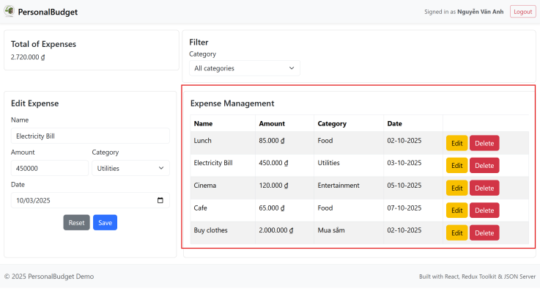

- Add expense form: name, amount, category, date (date input format: dd/MM/YYYY) (1 mark)
Add successfully (0.5 mark)
Validation rules: Name and Category must not be empty and Amount must be a valid number greater than 0 (0.25 mark).
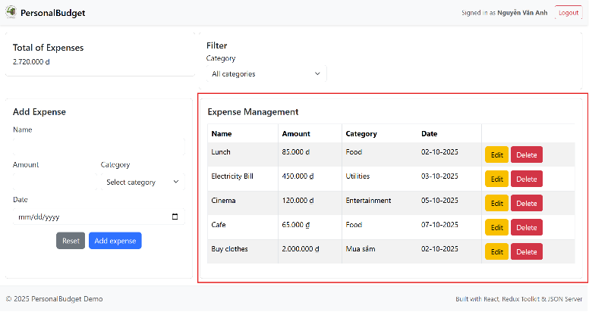
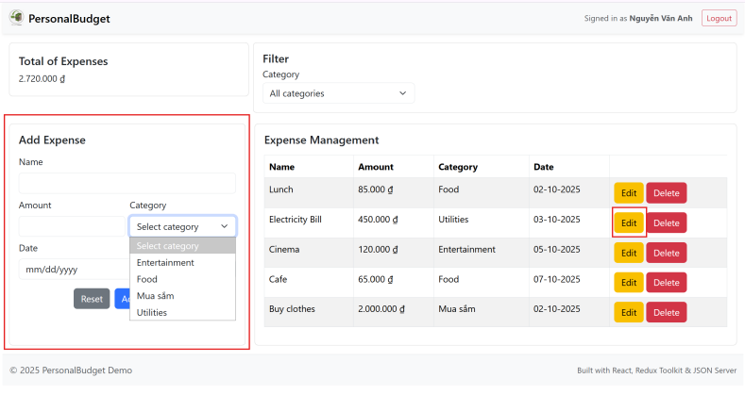

- Edit expense (0.75 mark)
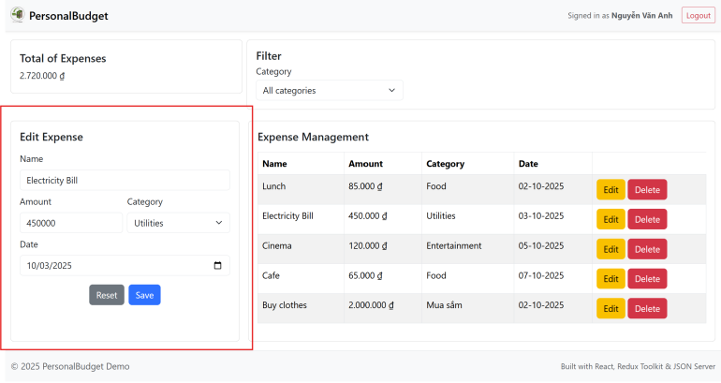
- Delete expense (0.5 mark)
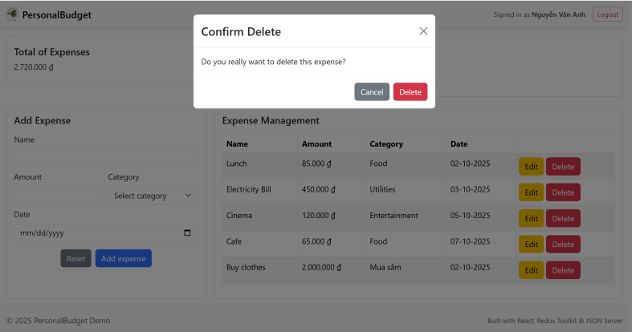
- Total of expenses (1.5 marks)
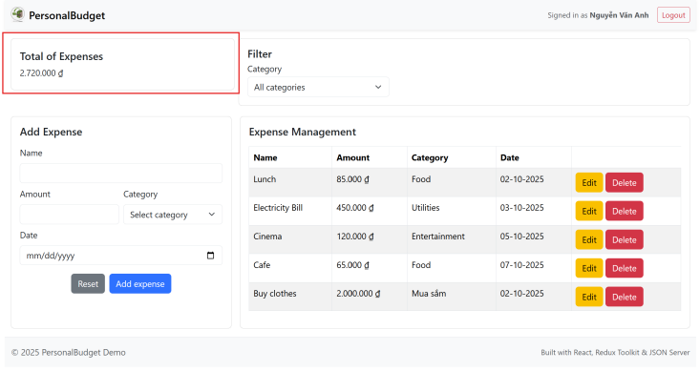
- Displays the total expenses (0.75 mark).
- Formatted in VND, e.g., 2,720,000 ₫ (0.25 mark).
- Automatically updates in real time when the amount changes (0.5 mark).
- Filter by category (1 mark)
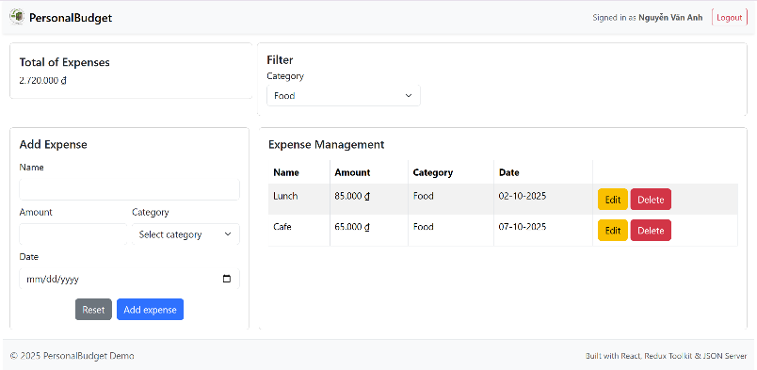
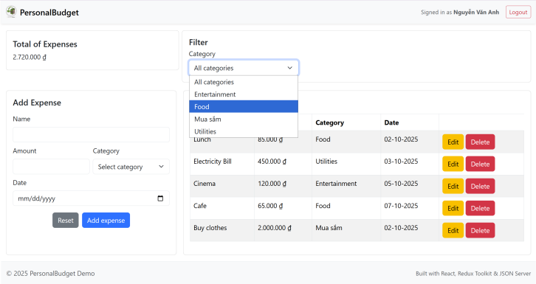
---END---

